Counseling
Is life stressing you out? You are not alone. Please call Catholic Charities at 270-683-1545 and mention CAP. We will direct you to a licensed counselor. You may also visit owensborodiocese.org/counseling.

Word of Life
“Adopting Andrew has made us more aware of God's power and of his love for us. We realize that he always has a perfect plan for our lives.”
Read more at www.bit.ly/AdoptionLoveStory.
USCCB Secretariat of Pro-Life Activities
“An Adoption Love Story

Immaculate Parish Seeking a Coordinator of Children’s Faith Formation (CFF)
For more information, visit the diocese website: www.owensborordiocese.org. All interested applicants please submit resume and cover letter to our Pastor at john.vaughan@pastoral.org.

RADA
I still have inventory of Rada items if anyone needs a gift(s) for a birthday, wedding, anniversary, etc. I am in the office Mon- Wed 7:30am-12:30pm. You can call me at 270-229-4164 and leave a message. Thanks

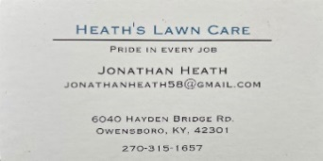

St. Francis de Sales Parish Seeking a Full- Time Director of Faith Formation and Family
For more information, visit the diocese website: www.owensborordiocese.org. All interested applicants please submit resume and cover letter to our Pastor at gary.clark@pastoral.org.

SAVE THE DATE: AUGUST 6th & 7th
for Brescia Sunday! More information closer to time.
Ursulines of MSJ Raffle: Buy your tickets for $5 each. Drawing will be held on Sunday, September 11th, 2022 at 4 pm in the Auditorium. Sr. Vivian has tickets if you want any!

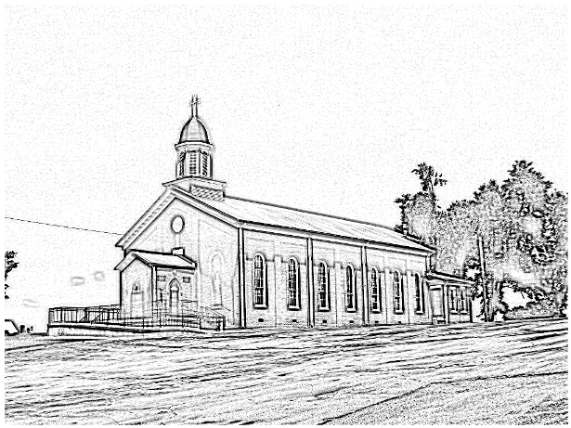
St. Alphonsus
Catholic Church
7925 State Route 500
Owensboro, Ky 42301
Office: 270-229-4164; Pastor’s Cell: 270-792-1202
Infant Baptism: Baptisms of children under the age of 7 are celebrated throughout the year. A parent preparation session is required. Please contact Fr. Anthoni.

Adult Initiation (RCIA): If you know anyone interested in learning more about the Catholic Faith, please encourage them to contact Fr. Anthoni or let us know and we’ll be happy to contact them.
Sacrament of Reconciliation: 4:00 pm on Saturday prior to Mass. Communal Celebrations during Lent and Advent.
Sacrament of Marriage: Please contact Fr. Anthoni for initial meeting, no later than six months prior to the desired wedding date. Contact Diane Dodson as well to reserve the parish hall.
Sacrament of the Sick: Please contact Fr. Anthoni if you or another parishioner is seriously ill (whether in the hospital or at home), and wish to be anointed.
Religious Education for Children attending public schools in kindergarten through 8th grade. Contact our Faith Formation Director at 270-229-4164.
New Members: Any newcomers to the parish can find a registration form in the rack in the vestibule. Just put in an envelope and drop in the collection basket. For more info contact the office 270-229-4164.

email Anthoni.ottagan@pastoral.org
Music Minister: Kay Beth Riney (270-929-8771)
Faith Formation Director/DRE: Sr. Vivian Bowles
(270-929-8826)
Sec./Bookkeeper: Shannon Jenkins (270-229-4164)
Youth Group Leader: Barbara Thomas (270-929-7583)
Church email: st.alphonsus@att.net
Website: saintalphonsusparish.org
(Someone will generally be in the Office from 8:00am-12:00pm Mon. through Friday; however, you can always call the appropriate staff member to be sure if you are planning to come by.)

Eucharistic Liturgies:
St. Alphonsus: Wednesdays @ 6:00 PM
Tuesday, Thursday & Fridays @ 7:30 AM
Saturday @ 5:00 PM
Sundays @ 8:00 AM
St. Elizabeth: Tuesdays @ 8:15 AM &Thursdays @ 6 PM
Sundays @ 9:30 AM
Parish Council Members & Responsibilities:
Nicole Murphy, Chairperson & Social Concerns
Tiffany Powers, Vice Chair & Catholic Schools Rep.
Shelly Blandford, Secretary
Christina Dant, Faith Formation & Youth Group
Jessica Green, Music Ministry & Liturgy
David Sinclair, Finance
Johnny Warren, Buildings & Grounds
Bobby Glenn, Buildings & Grounds
Kevin Clouse
Finance Council:
Diane Dodson, Chairperson
Faye Gabbard David Sinclair
Gary Cecil
ST. ALPHONSUS PARISH MISSION STATEMENT
St. Alphonsus Catholic Church, with its historical roots in St. Joseph, KY, is a faith community that seeks to serve, honor and praise the Blessed Trinity as a part of the universal Catholic Church and the Diocese of Owensboro, Kentucky by:
- Celebrating liturgies and rites of the Catholic faith
- Promoting Catholic beliefs and values through our daily works
- Seeking and providing knowledge of Christ’s word throughout the lifespan
- Providing a loving and supportive environment for all people in our church, local, national and worldwide communities
- Nurturing and growing the gifts that God has provided to us as individuals and as a group.

