Word of Life

“Married love differs from any other love in the world. By its nature, the love of husband and wife is so complete, so ordered to a lifetime of communion with God and each other, that it is open to creating a new human being they will love and care for together. … That power to create a new life with God isat the heart of what spouses share with each other.”

United States Conference of Catholic Bishops

“Married Love and the Gift of Life”

**Counseling**

Is life stressing you out? You are not alone. Please call Catholic Charities at 270-683-1545 and mention CAP. We will direct you to a licensed counselor. You may also visit owensborodiocese.org/counseling.



**SAVE THE DATE**

**AUGUST 6th & 7th**

**for Brescia Sunday! More information closer**

**to time.**

**RADA**

I still have inventory of Rada items if anyone needs a gift(s) for a birthday, wedding, anniversary, etc. I am in the office Mon- Wed 7:30am-12:30pm. You can call me at 270-229-4164 and leave a message. Thanks

**Ursuline Sisters of Mount Saint Joseph launch 52nd Annual Raffle**

The Mount Raffle has been a tradition for 52 years. It is an important source of funding for the Ursuline Sisters’ ministries as well as the retired sisters. **Tickets are still just $5 each.** Our top prize is **$10,000**! We have eight total prizes that also include a handmade queen-sized quilt (valued at $1,000) and cash prizes of $5000, $2500, $1000, $750, $500, $250. The drawing will take place on **Sunday, September 11th, 2022 at 4:00 PM.** We encourage supporters to buy tickets online at [**https://ursulinesmsj.org/mountraffle**](https://ursulinesmsj.org/mountraffle). If you would prefer to order tickets through the mail, write your check to the Ursuline Sisters and sent to: **Mount Raffle 8001 Cummings Rd. Maple Mount, KY 42356**. Escape to the Mount Quilt Bingo will return this year. Please join us on Sunday, September 11th, doors open at 12:30pm and bingo begins at 1:00pm in the Mount Auditorium. Seating is limited so register in advance. The registration fee is $25 and includes lunch with $1 bingo games for small or medium quilt prizes and $2 for large quilt prizes. Questions? Contact Carol Braden-Clarke, director of development at 270-229-2008, or [carol.braden-clarke@maplemount.org](mailto:carol.braden-clarke@maplemount.org). The Sisters keep all their friends and supporters in prayer.

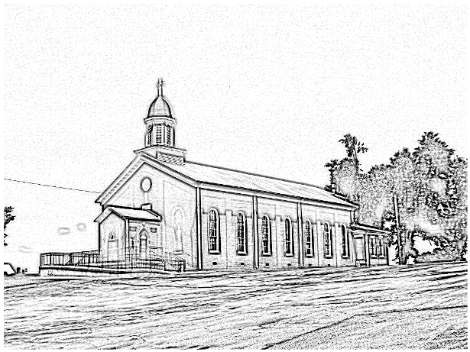St. Alphonsus

***Catholic Church  
 7925 State Route 500  
Owensboro, Ky 42301***

***Office: 270-229-4164; Pastor’s Cell: 270-792-1202***

***Infant Baptism:***Baptisms of children under the age of 7 are celebrated throughout the year. A parent preparation session is required. Please contact Fr. Anthoni.

***Adult Initiation (RCIA):***If you know anyone interested in learning more about the Catholic Faith, please encourage them to contact Fr. Anthoni or let us know and we’ll be happy to contact them.

***Sacrament of Reconciliation:*** *4:00 pm on Saturday prior to Mass.* **Communal Celebrations** during Lent and Advent.

***Sacrament of Marriage:***Please contact Fr. Anthoni for initial meeting, no later than six months prior to the desired wedding date. Contact Diane Dodson as well to reserve the parish hall.

***Sacrament of the Sick:*** Please contact Fr. Anthoni if you or another parishioner is seriously ill (whether in the hospital or at home), and wish to be anointed.

***Religious Education for Children***attending public schools in kindergarten through 8th grade. Contact our Faith Formation Director at 270-229-4164.

***New Members:*** Any newcomers to the parish can find a registration form in the rack in the vestibule. Just put in an envelope and drop in the collection basket. For more info contact the office 270-229-4164.

***email*** [***Anthoni.ottagan@pastoral.org***](mailto:Anthoni.ottagan@pastoral.org)

***Music Minister:*** *Kay Beth Riney (270-929-8771)****Faith Formation Director/DRE:*** *Sr. Vivian Bowles*

*(270-929-8826)*

***Sec./Bookkeeper:*** *Shannon Jenkins**(270-229-4164)*

***Youth Group Leader:*** *Barbara Thomas (270-929-7583)*

***Church email:*** [***st.alphonsus@att.net***](mailto:st.alphonsus@att.net)

***Website:*** *saintalphonsusparish.org*

*(Someone will generally be in the Office from 8:00am-12:00pm Mon. through Friday; however, you can always call the appropriate staff member to be sure if you are planning to come by.)*

***Eucharistic Liturgies:***

***St. Alphonsus: Wednesdays @ 6:00 PM***

***Tuesday, Thursday & Fridays @ 7:30 AM***

***Saturday @ 5:00 PM***

***Sundays @ 8:00 AM***

***St. Elizabeth: Tuesdays @ 8:15 AM &Thursdays @ 6 PM***

***Sundays @ 9:30 AM***

**Parish Council Members & Responsibilities:**

Nicole Murphy, Chairperson & Social Concerns

Tiffany Powers, Vice Chair & Catholic Schools Rep.

Shelly Blandford, Secretary

Christina Dant, Faith Formation & Youth Group

Jessica Green, Music Ministry & Liturgy

David Sinclair, Finance

Johnny Warren, Buildings & Grounds

Bobby Glenn, Buildings & Grounds

Kevin Clouse

**Finance Council:**

Diane Dodson, Chairperson

Faye Gabbard David Sinclair

Gary Cecil

**ST. ALPHONSUS PARISH MISSION STATEMENT**

St. Alphonsus Catholic Church, with its historical roots in St. Joseph, KY, is a faith community that seeks to serve, honor and praise the Blessed Trinity as a part of the universal Catholic Church and the Diocese of Owensboro, Kentucky by:

* Celebrating liturgies and rites of the Catholic faith
* Promoting Catholic beliefs and values through our daily works
* Seeking and providing knowledge of Christ’s word throughout the lifespan
* Providing a loving and supportive environment for all people in our church, local, national and worldwide communities
* Nurturing and growing the gifts that God has provided to us as individuals and as a group.