Word of Life
“The right to religious freedom has its foundation in the very dignity of the human person.”
Pope Paul VI, Dignitatis humanae (Declaration on Religious Freedom), 2. © 1965 Libreria Editrice Vaticana. Used with permission. All rights reserved.

Advent is just around the corner starting Sunday, November 28th. You can order religious gifts and supplies from www.Autom.com. They sell advent wreaths from $5.99 and up, rosaries, nativity sets, statues, and bibles. What a better Christmas gift to give a child than the knowledge of GOD’s love through a Children’s bible! Another site is Christianbook.com. They have a lot of nice items at reasonable prices.

Christmas/ New Year’s Youth Camp
Gasper River Catholic Youth Camp & Retreat Center hosts a Christmas/New Year's camp every year for 8th grade - high school students. Attending camp is a wonderful way to set the tone for 2022! The cost is $125, though there are some scholarships available. Spots are limited due to the current 60% capacity limit. If interested, visit gasperriverretreatcenter.org or call 270-781-2466.

Advent Retreat: Saying “Yes” with Mary
Mount Saint Joseph Auditorium on Saturday, December 11th from 9 a.m.- 2 p.m. The $39 fee includes lunch. Presented by Sr. Cheryl Clemons. Forms in the back of church or register at retreatcenter@maplemount.org.


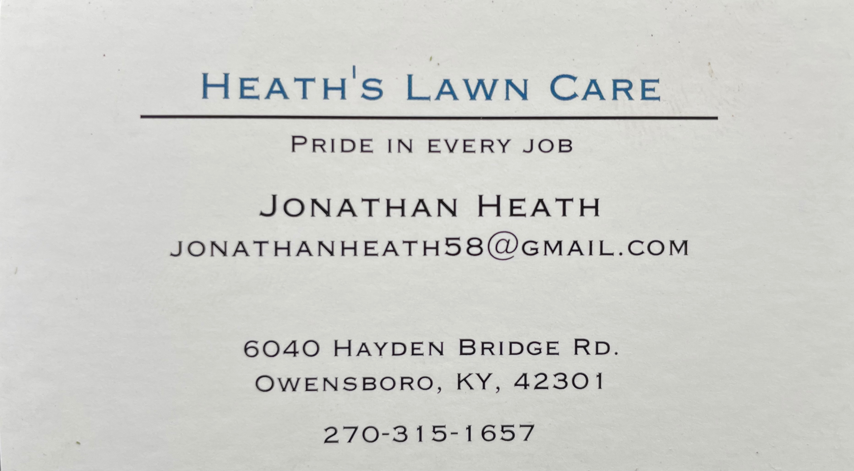











RADA
If I can get some orders between now and December 1st, I will make a new RADA order just in time for Christmas. Rada makes good Christmas, Anniversary, and Birthday Gifts. A new book came out in August 2021. It seems everything has gone to silver handles now and the prices went up 75 cents per item. I have new books if you want to take up an order. Order forms are in each book. There are some books in the back of church or in the office. Please have orders in by Wed. Dec. 1st to ensure we get them in time for Christmas with the holiday shipping delays. Thank You!

We have MANY of the 2014 St. Alphonsus Cookbooks left! These make GREAT gifts, especially at $5 each. Also, we have a small inventory of Rada. Scrip (gift cards) is another good gift idea and St. Alphonsus can earn money back on those. They are located in the back of OCHS open Mon, Tues, Thurs, and Fri from 9am-4pm. There are order forms in the back of church, so you can see what they have. Tell them the family is St. Alphonsus to help the church raise more money.

Counseling
Is the pandemic stressing you out? You are not alone. Please call Catholic Charities at 270-683-1545 and mention CAP. We will direct you to a licensed counselor. You may also visit owensborodiocese.org/counseling.







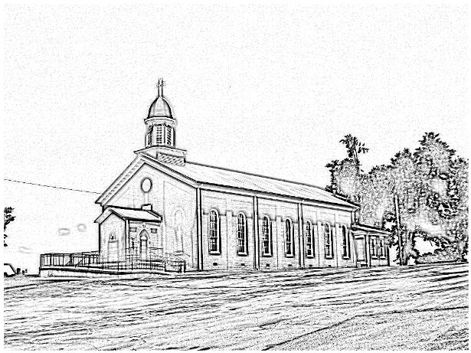

St. Alphonsus
Catholic Church
7925 State Route 500
Owensboro, Ky
Office: 270-229-4164; Pastor’s Cell: 270-792-1202
Pastoral Staff:
Pastor: Fr. Anthoni Ottagan (270-792-1202)
email Anthoni.ottagan@pastoral.org
Infant Baptism: Baptisms of children under the age of 7 are celebrated throughout the year. A parent preparation session is required. Please contact Fr. Anthoni.

Adult Initiation (RCIA): If you know anyone interested in learning more about the Catholic Faith, please encourage them to contact Fr. Anthoni or let us know and we’ll be happy to contact them.
Sacrament of Reconciliation: 4:00 pm on Saturday prior to Mass. Communal Celebrations during Lent and Advent.
Sacrament of Marriage: Please contact Fr. Anthoni for initial meeting, no later than six months prior to the desired wedding date. Contact Diane Dodson as well to reserve the parish hall.
Sacrament of the Sick: Please contact Fr. Anthoni if you or another parishioner is seriously ill (whether in the hospital or at home), and wish to be anointed.
Religious Education for Children attending public schools in kindergarten through 8th grade. Contact our Faith Formation Director at 270-229-4164.
New Members: Any newcomers to the parish can find a registration form in the rack in the vestibule. Just put in an envelope and drop in the collection basket. For more info contact the office 270-229-4164.

Music Minister: Kay Beth Riney (270-929-8771)
Faith Formation Director/DRE: Sr. Vivian Bowles
(270-929-8826)
Sec./Bookkeeper: Shannon Jenkins (270-229-4164)
Youth Group Leader: Barbara Thomas (270-929-7583)
Church email: st.alphonsus@att.net
Website: saintalphonsusparish.org
(Someone will generally be in the Office from 8:00am-12:00pm Mon. through Friday; however, you can always call the appropriate staff member to be sure if you are planning to come by.)

Eucharistic Liturgies:
St. Alphonsus: Tuesdays & Wednesdays – 6 PM
Thursday & Fridays - 7:30 AM
Saturday @ 5:00 PM
Sundays @ 8:00 AM
St. Elizabeth: Tuesdays – 8:15 AM; Thursdays – 6 PM
Sundays @ 9:30 AM

Parish Council Members & Responsibilities:
Nicole Murphy, Chairperson & Social Concerns
Tiffany Powers, Vice Chair & Catholic Schools Rep.
Shelly Blandford, Secretary
Christina Dant, Faith Formation & Youth Group
Jessica Green, Music Ministry & Liturgy
David Sinclair, Finance
Johnny Warren, Buildings & Grounds
Bobby Glenn, Buildings & Grounds
Don Peters
Kevin Clouse
Finance Council:
Diane Dodson, Chairperson
Faye Gabbard David Sinclair
Gary Cecil

ST. ALPHONSUS PARISH MISSION STATEMENT
St. Alphonsus Catholic Church, with its historical roots in St. Joseph, KY, is a faith community that seeks to serve, honor and praise the Blessed Trinity as a part of the universal Catholic Church and the Diocese of Owensboro, Kentucky by:
- Celebrating liturgies and rites of the Catholic faith
- Promoting Catholic beliefs and values through our daily works
- Seeking and providing knowledge of Christ’s word throughout the lifespan
- Providing a loving and supportive environment for all people in our church, local, national and worldwide communities
- Nurturing and growing the gifts that God has provided to us as individuals and as a group.

