Word of Life
“…the Supreme Court in Dobbs cleared the way for a paradigm shift in American law, allowing it to enlarge its boundaries to again welcome a segment of the human family that had been outside of its protections for close to half a century. Dobbs, then, is a victory for justice, the rule of law, and self-governance. But for those of us who have prayed for this moment to arrive, it is the time for a renewal and rededication of our efforts to build a culture of life and civilization of love.”
Archbishop William E. Lori, Chair of the USCCB Committee on Pro-Life Activities
“Building a Culture of Life in a Post-Roe World”

Counseling
Is life stressing you out? You are not alone. Please call Catholic Charities at 270-683-1545 and mention CAP. We will direct you to a licensed counselor. You may also visit owensborodiocese.org/counseling.

DEDICATION/MEMORIAL BRICK WALKWAY: We are still selling dedication/memorial bricks for our walkway from the parking lot to the cemetery in front of church. They are $100 each. Please see Shannon in the office or call her about ordering. We must meet a minimum amount to place a new order for bricks.

Scrip Office Hours
Monday, Tuesday, Thursday, Friday 9AM-4PM
You can get Christmas shopping done and earn money for St. Alphonsus at the same time! It’s a WIN-WIN!

K of C ANNUAL SAUSAGE SALE
SATURDAY, DECEMBER 3rd! Smoked and Un-smoked rolls will be $8.00. Contact a member, Joey Smith 270-903-8986, or Chris Kluck 270-993-9455 to order.
Thank You to our Night at the Races Sponsors

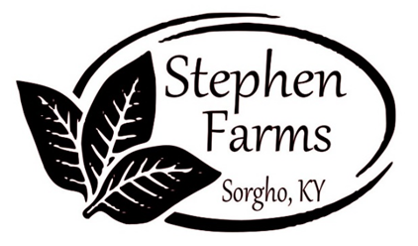
MSJ Activities and Pastoral Care Coordinator
This is a full-time, benefits eligible position. Duties include: working with the Director of Nursing to determine activities that provide spiritual, mental, physical and social stimulation; planning, developing and delivering a complete program of pastoral care to residents (and family as appropriate) and coordination of clergy, pastoral visitors and volunteers from the wider Motherhouse community, among other tasks as assigned. Bachelor’s Degree in related field is preferred, but equivalent experience will be considered. Candidates may apply on the Indeed website or by completing a paper application at their request.

RADA order in time for Christmas!
The cut off to order will be December 4th, so I can ensure we receive them in time. Typically, it only takes a few days to get them, but with the shipping issues we will play it safe. Leave orders in the black box outside office door, drop in the collection, or call me at 270-229-4164.
Thanks, Shannon
RADA
I still have inventory of Rada items if anyone needs a gift(s) for a birthday, wedding, anniversary, etc. I am in the office Mon- Wed 7:30am-12:30pm. You can call me at 270-229-4164 and leave a message. Thanks, Shannon

Diocese of Owensboro -Director of Communications
Minimum of Bachelors in communications, public relations, mass media, marketing, journalism or related field. Comfortable with electronic communications. Familiar with audio or virtual alternatives, and design software. Excellent communication skills, human relations and interpersonal skills. Must be a self-starter, well organized, a team player, and able to travel and be available evening and weekend work as necessary. Please submit a resume and cover letter to: diocesehr@pastoral.org. Applications accepted until position is filled.
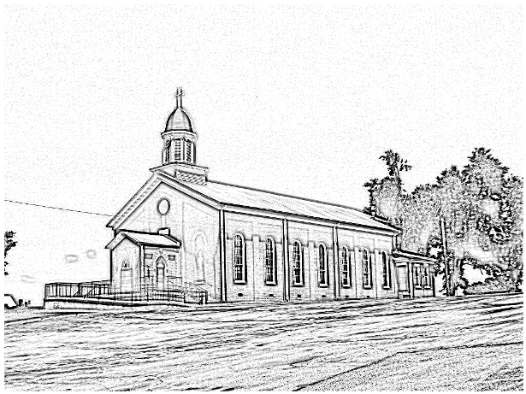

St. Alphonsus
Catholic Church
7925 State Route 500
Owensboro, Ky 42301
Office: 270-229-4164; Pastor’s Cell: 270-792-1202
email Anthoni.ottagan@pastoral.org
Music Minister: Kay Beth Riney (270-929-8771)
Faith Formation Director/DRE: Sr. Vivian Bowles
(270-929-8826)
Sec./Bookkeeper: Shannon Jenkins (270-229-4164)
Youth Group Leader: Barbara Thomas (270-929-7583)
Church email: st.alphonsus@att.net
Website: saintalphonsusparish.org
(Someone will generally be in the Office from 8:00am-12:00pm Mon. through Friday; however, you can always call the appropriate staff member to be sure if you are planning to come by.)

Eucharistic Liturgies:
St. Alphonsus: Wednesdays @ 6:00 PM
Tuesday, Thursday & Fridays @ 7:30 AM
Saturday @ 5:00 PM
Sundays @ 8:00 AM
St. Elizabeth: Tuesdays @ 8:15 AM
1st Thursday of the month @ 6 PM
Sundays @ 9:30 AM
Parish Council Members & Responsibilities:
Nicole Murphy, Chairperson & Social Concerns
Tiffany Powers, Vice Chair & Catholic Schools Rep.
Shelly Blandford, Secretary
Christina Dant, Faith Formation & Youth Group
Jessica Green, Music Ministry & Liturgy
David Sinclair, Finance
Johnny Warren, Buildings & Grounds
Bobby Glenn, Buildings & Grounds
Kevin Clouse
Finance Council:
Diane Dodson, Chairperson
Faye Gabbard David Sinclair
Gary Cecil
ST. ALPHONSUS PARISH MISSION STATEMENT
St. Alphonsus Catholic Church, with its historical roots in St. Joseph, KY, is a faith community that seeks to serve, honor and praise the Blessed Trinity as a part of the universal Catholic Church and the Diocese of Owensboro, Kentucky by:
- Celebrating liturgies and rites of the Catholic faith
- Promoting Catholic beliefs and values through our daily works
- Seeking and providing knowledge of Christ’s word throughout the lifespan
- Providing a loving and supportive environment for all people in our church, local, national and worldwide communities
- Nurturing and growing the gifts that God has provided to us as individuals and as a group.

Infant Baptism: Baptisms of children under the age of 7 are celebrated throughout the year. A parent preparation session is required. Please contact Fr. Anthoni.

Adult Initiation (RCIA): If you know anyone interested in learning more about the Catholic Faith, please encourage them to contact Fr. Anthoni or let us know and we’ll be happy to contact them.
Sacrament of Reconciliation: 4:00 pm on Saturday prior to Mass. Communal Celebrations during Lent and Advent.
Sacrament of Marriage: Please contact Fr. Anthoni for initial meeting, no later than six months prior to the desired wedding date. Contact Diane Dodson as well to reserve the parish hall.
Sacrament of the Sick: Please contact Fr. Anthoni if you or another parishioner is seriously ill (whether in the hospital or at home), and wish to be anointed.
Religious Education for Children attending public schools in kindergarten through 8th grade. Contact our Faith Formation Director at 270-229-4164.
New Members: Any newcomers to the parish can find a registration form in the rack in the vestibule. Just put in an envelope and drop in the collection basket. For more info contact the office 270-229-4164.

