Word of Life
“We thank you, heroic mothers, for your invincible love! We thank you for your intrepid trust in God and in his love. We thank you for the sacrifice of your life” (EV 86). Pope Saint John Paul II, Evangelium vitae © 1995, Libreria Editrice Vaticana. Used with permission. All rights reserved.
Counseling
Is life stressing you out? You are not alone. Please call Catholic Charities at 270-683-1545 and mention CAP. We will direct you to a licensed counselor. You may also visit owensborodiocese.org/counseling.

18th Rural Life Celebration
Sunday, August 7, 2022, 5:00 pm @
Owensboro Convention Center
A free meal will be served starting at 5:00 pm with a short program. This year, special recognition will be given to Mr. Gene Glenn with the Lifetime Achievement Award. Come help us honor his contributions to our community. Event sponsored by the Diocese of Owensboro Rural Life Committee.​

Holy Spirit Parish in Bowling Green, KY- Facility and Grounds Maintenance
Responsible for buildings and grounds at 4754 Smallhouse Rd., including rectory, SVDP barn, church, offices, classrooms and rental house. For more information visit us online at https://holyspiritcatholic.org/job-opportunities. All interested applicants may submit a resume and cover letter to jobs@holyspiritcatholic.org .

Ursuline Sisters of Mount Saint Joseph launch 52nd Annual Raffle
The Mount Raffle has been a tradition for 52 years. It is an important source of funding for the Ursuline Sisters’ ministries as well as the retired sisters. Tickets are still just $5 each. Our top prize is $10,000! We have eight total prizes that also include a handmade queen-sized quilt (valued at $1,000) and cash prizes of $5000, $2500, $1000, $750, $500, $250. The drawing will take place on Sunday, September 11th, 2022 at 4:00 PM. We encourage supporters to buy tickets online at https://ursulinesmsj.org/mountraffle. If you would prefer to order tickets through the mail, write your check to the Ursuline Sisters and sent to: Mount Raffle 8001 Cummings Rd. Maple Mount, KY 42356. Escape to the Mount Quilt Bingo will return this year. Please join us on Sunday, September 11th, doors open at 12:30pm and bingo begins at 1:00pm in the Mount Auditorium. Seating is limited so register in advance. The registration fee is $25 and includes lunch with $1 bingo games for small or medium quilt prizes and $2 for large quilt prizes. Questions? Contact Carol Braden-Clarke, director of development at 270-229-2008, or carol.braden-clarke@maplemount.org. The Sisters keep all their friends and supporters in prayer. Sr. Vivian has tickets for sale also!

Catholic Charities Collecting Items for Eastern, KY Flood Relief
Catholic Charities is currently accepting the following items to fill a trailer: toothbrushes, toothpaste, over the counter medication (Tylenol, ibuprofen, Advil, Motrin, etc), bleach, cleaners, hand soap, wet/ body wipes, liquid body soap, dish soap, laundry detergent, toilet paper, paper towels, Lysol wipes, shovels, diapers, formula, work gloves, safety glasses, masks for mold, fans, plastic gas containers, brooms, rakes and tarps. Items may be dropped off at the Catholic Charities building located at 529 Cedar Street, Owensboro, KY 42301 between the hours of 8 AM until 4:30 PM Monday through Thursday. Once Catholic Charities has enough donated items to fill a trailer, it will be taken to a location determined by Catholic Charities USA. If you want to give a monetary donation, please make the check out to Catholic Charities with Eastern KY Flooding in the memo. Those can be dropped off or mailed to Catholic Charities, 600 Locust Street, Owensboro, KY 42301.
RADA
I still have inventory of Rada items if anyone needs a gift(s) for a birthday, wedding, anniversary, etc. I am in the office Mon- Wed 7:30am-12:30pm. You can call me at 270-229-4164 and leave a message. Thanks

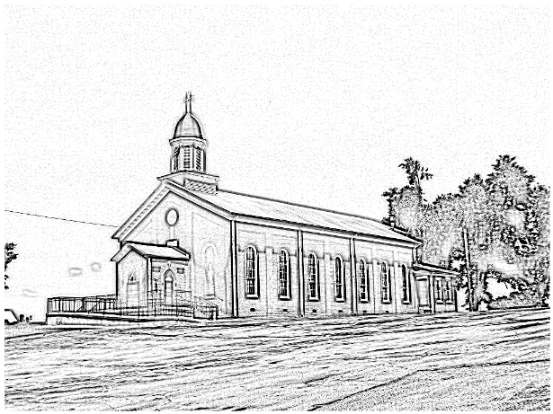
St. Alphonsus
Catholic Church
7925 State Route 500
Owensboro, Ky 42301
Office: 270-229-4164; Pastor’s Cell: 270-792-1202
Infant Baptism: Baptisms of children under the age of 7 are celebrated throughout the year. A parent preparation session is required. Please contact Fr. Anthoni.

Adult Initiation (RCIA): If you know anyone interested in learning more about the Catholic Faith, please encourage them to contact Fr. Anthoni or let us know and we’ll be happy to contact them.
Sacrament of Reconciliation: 4:00 pm on Saturday prior to Mass. Communal Celebrations during Lent and Advent.
Sacrament of Marriage: Please contact Fr. Anthoni for initial meeting, no later than six months prior to the desired wedding date. Contact Diane Dodson as well to reserve the parish hall.
Sacrament of the Sick: Please contact Fr. Anthoni if you or another parishioner is seriously ill (whether in the hospital or at home), and wish to be anointed.
Religious Education for Children attending public schools in kindergarten through 8th grade. Contact our Faith Formation Director at 270-229-4164.
New Members: Any newcomers to the parish can find a registration form in the rack in the vestibule. Just put in an envelope and drop in the collection basket. For more info contact the office 270-229-4164.

email Anthoni.ottagan@pastoral.org
Music Minister: Kay Beth Riney (270-929-8771)
Faith Formation Director/DRE: Sr. Vivian Bowles
(270-929-8826)
Sec./Bookkeeper: Shannon Jenkins (270-229-4164)
Youth Group Leader: Barbara Thomas (270-929-7583)
Church email: st.alphonsus@att.net
Website: saintalphonsusparish.org
(Someone will generally be in the Office from 8:00am-12:00pm Mon. through Friday; however, you can always call the appropriate staff member to be sure if you are planning to come by.)

Eucharistic Liturgies:
St. Alphonsus: Wednesdays @ 6:00 PM
Tuesday, Thursday & Fridays @ 7:30 AM
Saturday @ 5:00 PM
Sundays @ 8:00 AM
St. Elizabeth: Tuesdays @ 8:15 AM
1st Thursday of the month @ 6 PM
Sundays @ 9:30 AM
Parish Council Members & Responsibilities:
Nicole Murphy, Chairperson & Social Concerns
Tiffany Powers, Vice Chair & Catholic Schools Rep.
Shelly Blandford, Secretary
Christina Dant, Faith Formation & Youth Group
Jessica Green, Music Ministry & Liturgy
David Sinclair, Finance
Johnny Warren, Buildings & Grounds
Bobby Glenn, Buildings & Grounds
Kevin Clouse
Finance Council:
Diane Dodson, Chairperson
Faye Gabbard David Sinclair
Gary Cecil
ST. ALPHONSUS PARISH MISSION STATEMENT
St. Alphonsus Catholic Church, with its historical roots in St. Joseph, KY, is a faith community that seeks to serve, honor and praise the Blessed Trinity as a part of the universal Catholic Church and the Diocese of Owensboro, Kentucky by:
- Celebrating liturgies and rites of the Catholic faith
- Promoting Catholic beliefs and values through our daily works
- Seeking and providing knowledge of Christ’s word throughout the lifespan
- Providing a loving and supportive environment for all people in our church, local, national and worldwide communities
- Nurturing and growing the gifts that God has provided to us as individuals and as a group.

