Word of Life

“Because of our belief and hope in the Resurrection, we can face death not with fear, but with preparation…. We prepare for eternal life by choosing to love and follow God now, in our daily lives and decisions.” Read more at www.respectlife.org/end-of-life-considerations.

USCCB Secretariat of Pro-Life Activities

“Catholic Considerations for Our Earthly Passing”

**Counseling**

Is life stressing you out? You are not alone. Please call Catholic Charities at 270-683-1545 and mention CAP. We will direct you to a licensed counselor. You may also visit owensborodiocese.org/counseling.



**Immaculate Parish Seeking a Coordinator of Children’s Faith Formation (CFF)**

For more information, visit the diocese website: [www.owensborordiocese.org](http://www.owensborordiocese.org). All interested applicants please submit resume and cover letter to our Pastor at [**john.vaughan@pastoral.org**](mailto:john.vaughan@pastoral.org)**.**

**RADA**

I still have inventory of Rada items if anyone needs a gift(s) for a birthday, wedding, anniversary, etc. I am in the office Mon- Wed 7:30am-12:30pm. You can call me at 270-229-4164 and leave a message. Thanks

**Ursuline Sisters of Mount Saint Joseph launch 52nd Annual Raffle**

The Mount Raffle has been a tradition for 52 years. It is an important source of funding for the Ursuline Sisters’ ministries as well as the retired sisters. **Tickets are still just $5 each.** Our top prize is **$10,000**! We have eight total prizes that also include a handmade queen-sized quilt (valued at $1,000) and cash prizes of $5000, $2500, $1000, $750, $500, $250. The drawing will take place on **Sunday, September 11th, 2022 at 4:00 PM.** We encourage supporters to buy tickets online at [**https://ursulinesmsj.org/mountraffle**](https://ursulinesmsj.org/mountraffle). If you would prefer to order tickets through the mail, write your check to the Ursuline Sisters and sent to: **Mount Raffle 8001 Cummings Rd. Maple Mount, KY 42356**. Escape to the Mount Quilt Bingo will return this year. Please join us on Sunday, September 11th, doors open at 12:30pm and bingo begins at 1:00pm in the Mount Auditorium. Seating is limited so register in advance. The registration fee is $25 and includes lunch with $1 bingo games for small or medium quilt prizes and $2 for large quilt prizes. Questions? Contact Carol Braden-Clarke, director of development at 270-229-2008, or [carol.braden-clarke@maplemount.org](mailto:carol.braden-clarke@maplemount.org). The Sisters keep all their friends and supporters in prayer.

**SAVE THE DATE: AUGUST 6th & 7th**

**for Brescia Sunday! More information closer to time.**

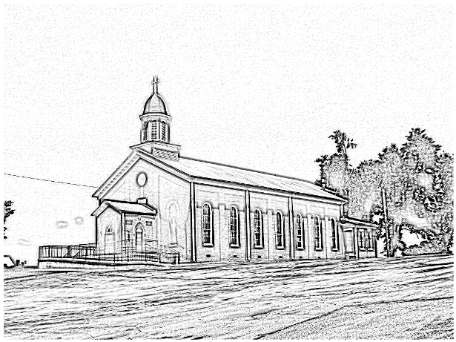St. Alphonsus

***Catholic Church  
 7925 State Route 500  
Owensboro, Ky 42301***

***Office: 270-229-4164; Pastor’s Cell: 270-792-1202***

***Infant Baptism:***Baptisms of children under the age of 7 are celebrated throughout the year. A parent preparation session is required. Please contact Fr. Anthoni.

***Adult Initiation (RCIA):***If you know anyone interested in learning more about the Catholic Faith, please encourage them to contact Fr. Anthoni or let us know and we’ll be happy to contact them.

***Sacrament of Reconciliation:*** *4:00 pm on Saturday prior to Mass.* **Communal Celebrations** during Lent and Advent.

***Sacrament of Marriage:***Please contact Fr. Anthoni for initial meeting, no later than six months prior to the desired wedding date. Contact Diane Dodson as well to reserve the parish hall.

***Sacrament of the Sick:*** Please contact Fr. Anthoni if you or another parishioner is seriously ill (whether in the hospital or at home), and wish to be anointed.

***Religious Education for Children***attending public schools in kindergarten through 8th grade. Contact our Faith Formation Director at 270-229-4164.

***New Members:*** Any newcomers to the parish can find a registration form in the rack in the vestibule. Just put in an envelope and drop in the collection basket. For more info contact the office 270-229-4164.

***email*** [***Anthoni.ottagan@pastoral.org***](mailto:Anthoni.ottagan@pastoral.org)

***Music Minister:*** *Kay Beth Riney (270-929-8771)****Faith Formation Director/DRE:*** *Sr. Vivian Bowles*

*(270-929-8826)*

***Sec./Bookkeeper:*** *Shannon Jenkins**(270-229-4164)*

***Youth Group Leader:*** *Barbara Thomas (270-929-7583)*

***Church email:*** [***st.alphonsus@att.net***](mailto:st.alphonsus@att.net)

***Website:*** *saintalphonsusparish.org*

*(Someone will generally be in the Office from 8:00am-12:00pm Mon. through Friday; however, you can always call the appropriate staff member to be sure if you are planning to come by.)*

***Eucharistic Liturgies:***

***St. Alphonsus: Wednesdays @ 6:00 PM***

***Tuesday, Thursday & Fridays @ 7:30 AM***

***Saturday @ 5:00 PM***

***Sundays @ 8:00 AM***

***St. Elizabeth: Tuesdays @ 8:15 AM &Thursdays @ 6 PM***

***Sundays @ 9:30 AM***

**Parish Council Members & Responsibilities:**

Nicole Murphy, Chairperson & Social Concerns

Tiffany Powers, Vice Chair & Catholic Schools Rep.

Shelly Blandford, Secretary

Christina Dant, Faith Formation & Youth Group

Jessica Green, Music Ministry & Liturgy

David Sinclair, Finance

Johnny Warren, Buildings & Grounds

Bobby Glenn, Buildings & Grounds

Kevin Clouse

**Finance Council:**

Diane Dodson, Chairperson

Faye Gabbard David Sinclair

Gary Cecil

**ST. ALPHONSUS PARISH MISSION STATEMENT**

St. Alphonsus Catholic Church, with its historical roots in St. Joseph, KY, is a faith community that seeks to serve, honor and praise the Blessed Trinity as a part of the universal Catholic Church and the Diocese of Owensboro, Kentucky by:

* Celebrating liturgies and rites of the Catholic faith
* Promoting Catholic beliefs and values through our daily works
* Seeking and providing knowledge of Christ’s word throughout the lifespan
* Providing a loving and supportive environment for all people in our church, local, national and worldwide communities
* Nurturing and growing the gifts that God has provided to us as individuals and as a group.